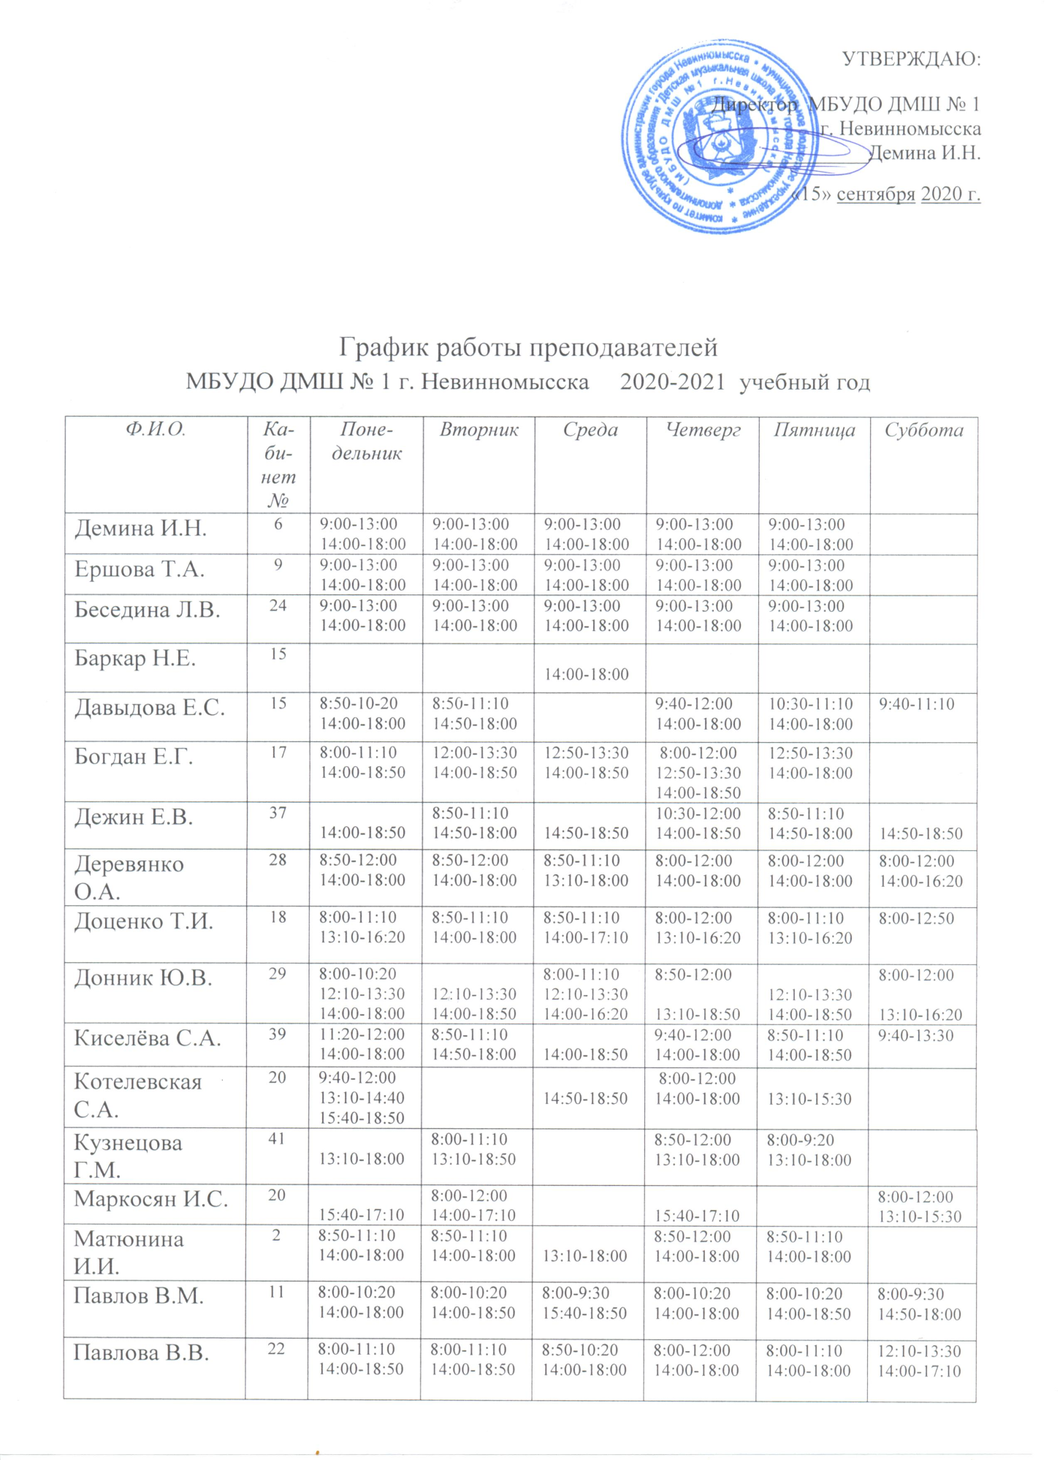

Пашенькина Т.В. | 34 | 8:00-10:20  14:00-17:20 | 8:00-12:00  13:10-18:50 | 9:40-12:00  13:10-18:50 | 8:00-12:00  13:10-18:50 | 8:00-10:20  14:00-17:10 | 9:40-11:10  12:00-15:20
Пащенко Л.В. | 13 | 14:50-18:00 | 16:30-18:00 |  | 15:40-18:00 | 16:30-18:00
Попова О.Н. | 14 | 8:00-10:20  12:50-17:20 | 8:00-11:10  12:50-17:20 | 14:00-18:00 | 9:40-12:00  12:50-13:30  14:00-18:00 | 8:50-10:20  12:50-13:30  14:00-18:50
Просвирина Е.В. | 30 | 8:00-12:00  14:00-18:50 | 8:00-12:00  14:00-18:00 | 14:00-18:00 | 8:00-12:00  13:10-18:00 | 8:00-12:50  14:00-18:50 | 8:00-12:00  13:10-15:30
Романюк Н.П. | 23 | 10:30-12:00  13:10-17:10 | 8:50-10:20  13:10-18:00 | 13:10-17:40 | 8:50-12:00  13:10-18:00 | 10:30-12:00  13:10-18:00
Сосина Л.Г. | 40 | 8:50-11:10  12:00-13:30  14:00-15:30 | 8:50-11:10  12:50-13:30  14:00-18:50 | 8:50-11:10  12:50-13:30  14:00-18:50 | 8:00-12:00  12:50-13:30  14:00-18:00 | 10:30-12:00  12:50-13:30  14:00-16:20 | 10:30-12:00  12:50-13:30  14:00-16:20
Старцева Ж.В. | 21 | 9:40-11:10  14:00-18:00 | 8:50-11:10  14:00-18:00 | 14:00-18:00 | 8:50-12:00  14:50-17:10 | 8:50-11:10  14:00-18:00
Старцев П.Д. | 12 | 8:00-11:10  14:00-18:50 | 8:00-10:20  14:00-18:50 | 14:50-18:50 | 8:00-12:00  14:00-18:50 | 8:00-11:10  14:00-18:50
Титовская Н.Ю. | 19 | 8:50-11:10  13:10-15:30  16:30-19:30 | 13:10-15:30  16:30-18:50 | 13:10-15:30  16:30-19:30 | 8:50-10:20  13:10-15:30  16:30-18:50 | 8:00-10:20  13:10-15:30  16:30-19:30
Тымчак М.Р. | 41, 35 | 8:00-9:30  14:00-16:20 | 8:00-9:30  14:00-15:30 | 8:00-12:00  12:30-18:50 | 13:10-16:20
Федорина М.Н. | 35 | 8:00-10:20  12:50-13:30  14:00-18:50 | 8:00-10:20  12:50-13:30  14:00-18:50 | 12:50-13:30  14:00-18:50 | 8:00-9:30  10:30-12:00  14:00-18:50 | 14:00-18:50 | 8:00-12:00  12:50-13:30  14:00-17:10
Хачанян В.Г. | 26 | 8:00-10:20  14:50-18:50 | 8:00-10:20  14:00-18:00 | 8:00-12:00  14:00-15:30 | 8:00-12:00  14:00-18:50 | 9:40-11:10  14:50-18:50 | 10:30-12:50
Храмова Е.А. | 36 | 9:40-11:10  13:10-17:50 | 11:20-13:30  14:00-18:50 | 14:50-18:00 | 10:30-12:00  13:10-18:50 | 10:30-13:30  14:00-18:50 | 8:50-12:50  14:50-18:00
Чепцова М.А. | 25 | 8:00-12:00  13:10-18:50 | 8:00-12:00  14:00-18:50 | 14:50-17:10 | 8:00-12:00  13:10-18:50 | 8:00-11:10  13:10-18:00 | 14:50-15:30
Чернышёва А.В. | 3 | 8:50-11:10  14:50-18:00 | 8:50-12:50  14:50-18:00 | 8:50-10:20 | 8:50-10:20  14:50-15:30 | 8:50-11:10  14:50-17:10
Чугаева М.Н. | 38 | 9:40-10:20  12:00-13:30  14:00-18:00 | 8:00-12:00  12:50-13:30  16:30-18:50 | 12:00-13:30  14:00-16:20 | 10:30-11:10  12:00-13:30  14:00-18:50 | 8:00-11:10  12:00-13:30  14:00-18:00 | 11:10-13:30  14:00-14:40
Шулепова Н.В. | 5 | 8:00-11:10  13:10-18:00 | 8:00-11:10  13:10-17:10 |  | 8:00-12:00  13:10-17:10 | 8:00-12:00  13:10-16:20
Якимова О.А. | 4 | 8:50-9:30  13:10-16:20 | 8:50-10:20  14:00-17:10 |  | 9:40-12:00  14:00-17:10 | 14:00-16:20

